第一幕a young girl named Ann wearing a school uniform and glasses, with straight hair in a ponytail, a bright smile, and an intelligent, curious personality. Ann wakes up in the morning, stretches happily, and gets ready for the day. She puts on her school uniform and prepares to go outside.

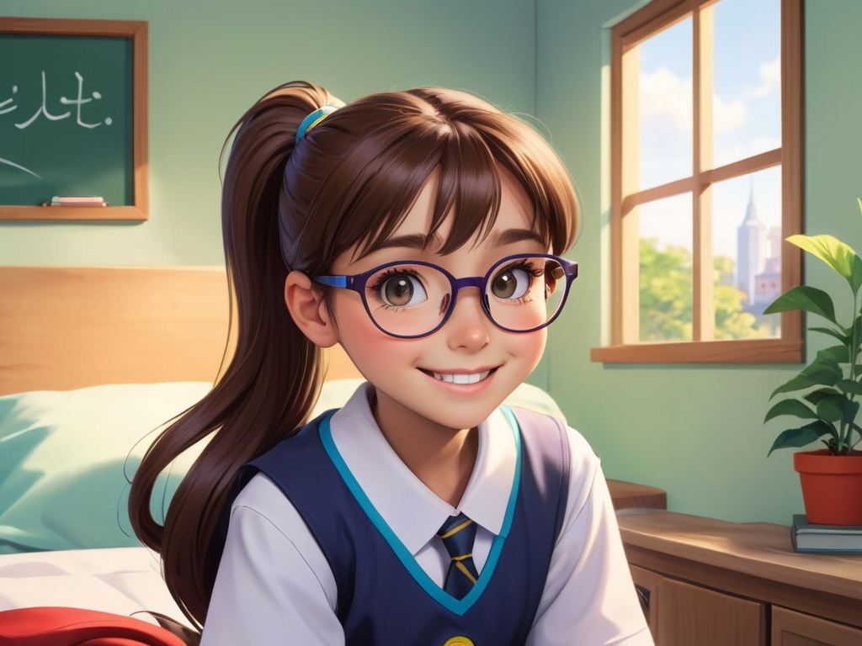

第二幕a young girl named Ann wearing a school uniform and glasses, with straight hair in a ponytail, a bright smile, and an intelligent, curious personality. Ann arrives at school and discovers that they are going to learn new things today. She feels curious and excited. The teacher tells her that learning is like an adventure—sometimes challenging but full of surprises.

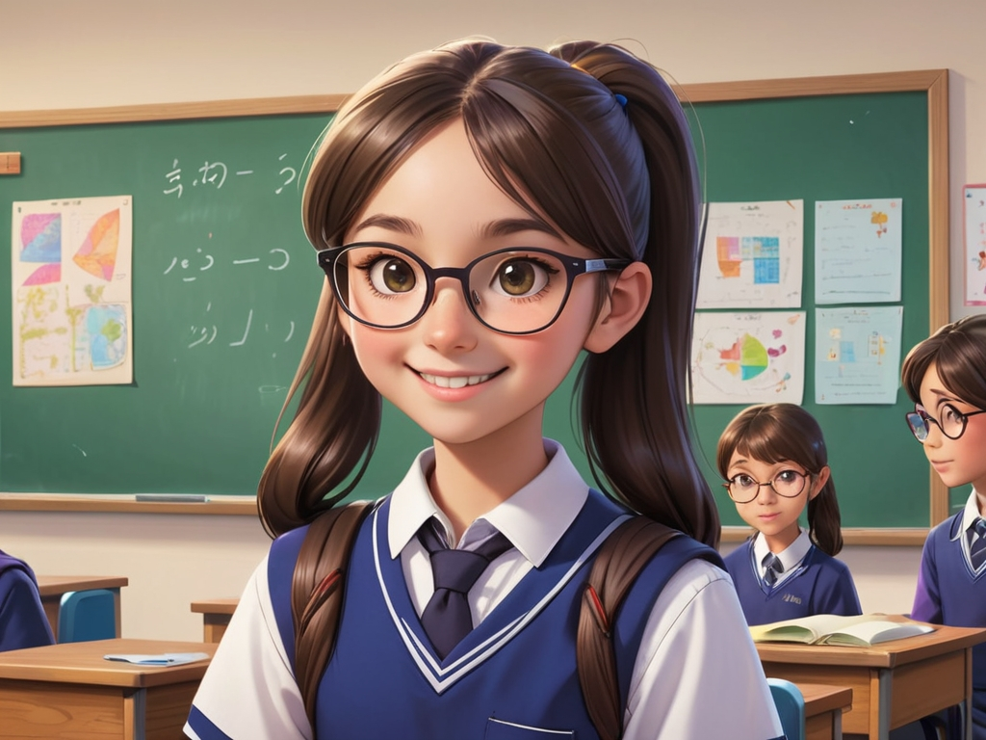

第三幕a young girl named Ann wearing a school uniform and glasses, with straight hair in a ponytail, a bright smile, and an intelligent, curious personality. Ann struggles with a math problem and feels a bit discouraged. She starts to doubt whether she can solve it.



第四幕a young girl named Ann wearing a school uniform and glasses, with straight hair in a ponytail, a bright smile, and an intelligent, curious personality. Ann decides to ask the teacher and her classmates for help. The teacher explains the math problem patiently, and her friends offer helpful tips that make everything clearer.

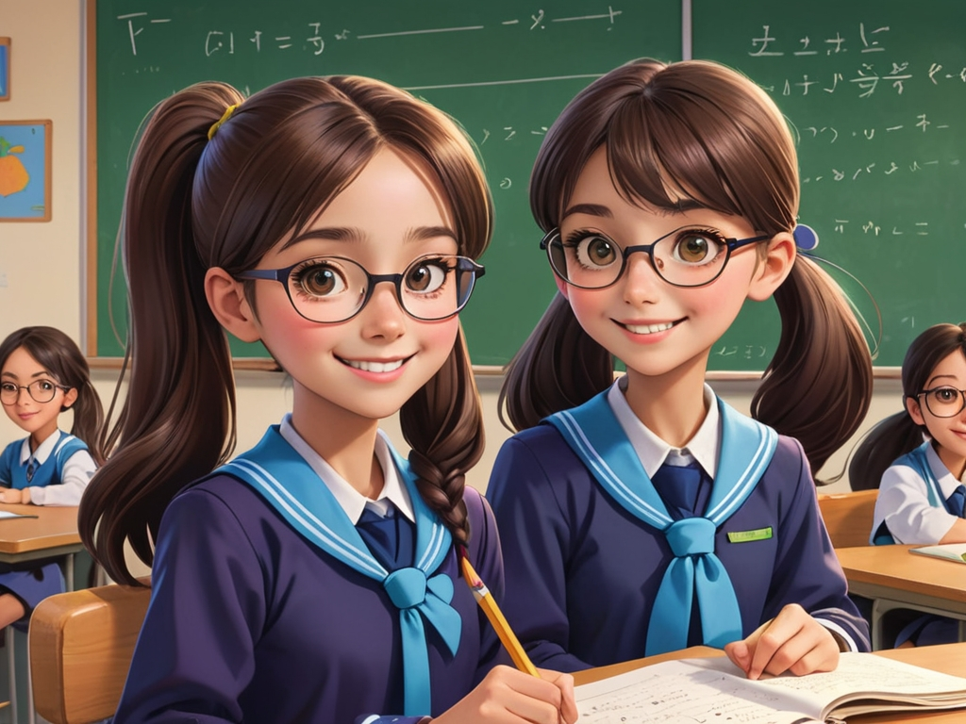

第五幕a young girl named Ann wearing a school uniform and glasses, with straight hair in a ponytail, a bright smile, and an intelligent, curious personality. In art class, Ann tries painting for the first time. Though her painting isn’t perfect, she doesn't get discouraged and decides to keep trying.

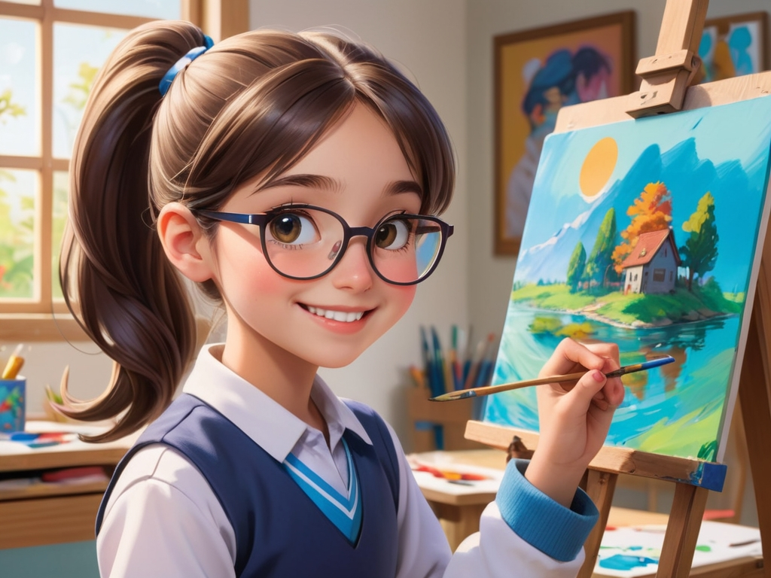

第六幕a young girl named Ann wearing a school uniform and glasses, with straight hair in a ponytail, a bright smile, and an intelligent, curious personality. While doing her homework, Ann makes a few small mistakes. She feels a little upset but reminds herself that mistakes are part of learning, and she chooses to learn from them.

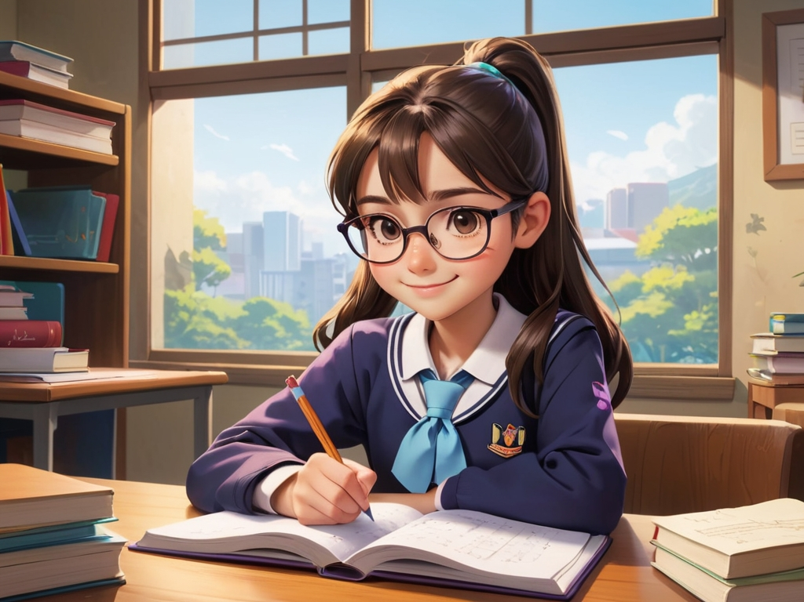

第七幕a young girl named Ann wearing a school uniform and glasses, with straight hair in a ponytail, a bright smile, and an intelligent, curious personality. Ann finishes her math homework and paints a beautiful picture. She shares her work with her teacher and classmates, and they praise her for her effort.

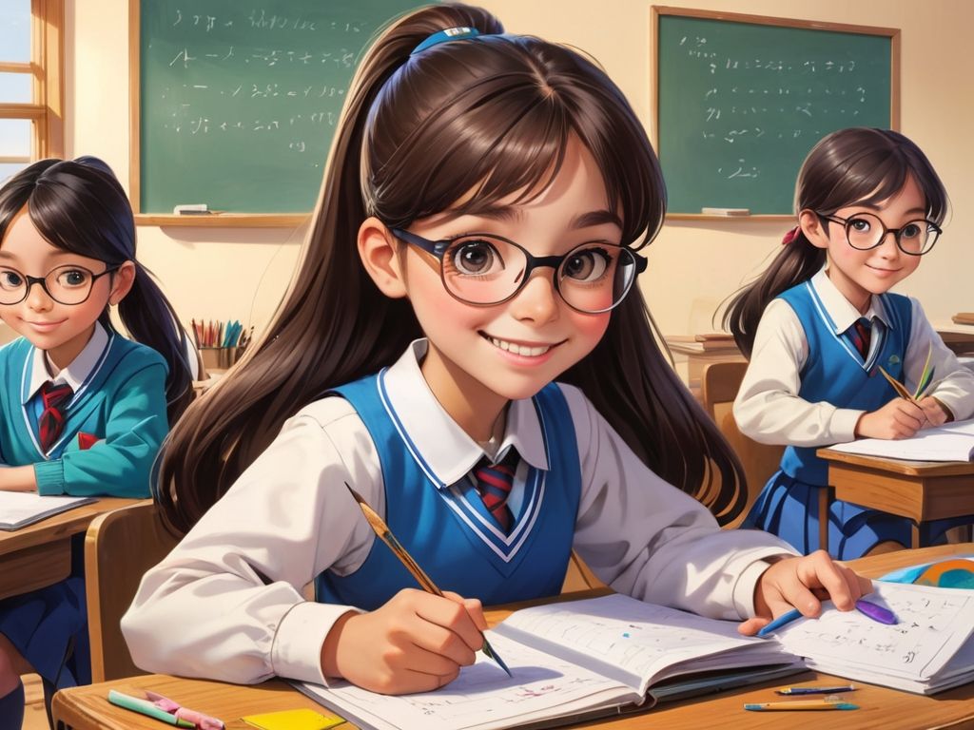

第八幕a young girl named Ann wearing a school uniform and glasses, with straight hair in a ponytail, a bright smile, and an intelligent, curious personality. Ann participates in a race at the sports event, but despite her efforts, she falls behind the other students. She feels a little discouraged.

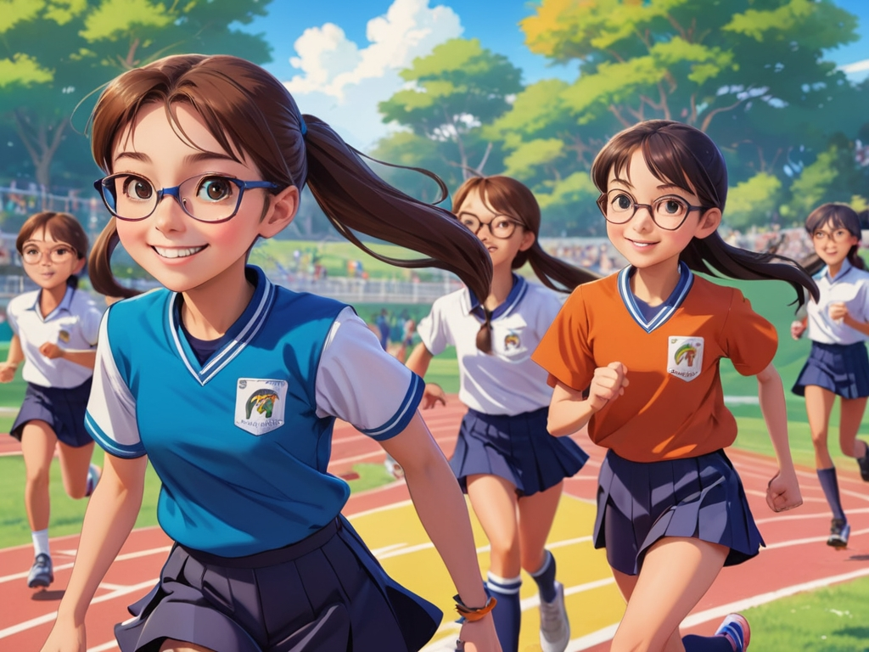

第九幕a young girl named Ann wearing a school uniform and glasses, with straight hair in a ponytail, a bright smile, and an intelligent, curious personality. Even after her setback, Ann decides to keep practicing running every day. She believes that with effort, she will eventually improve.



第十幕a young girl named Ann wearing a school uniform and glasses, with straight hair in a ponytail, a bright smile, and an intelligent, curious personality. At the end of the day, Ann walks home and reflects on everything she learned. She’s thankful for the day’s experiences and looks forward to tomorrow’s adventures.

